**Prepare / Support Product Test**

**Module Description**

During this final test phase, you will review the entry criteria for the Product Test. This module will also see your role change to that of a fix-it team.

**Scenario**

The project team has successfully completed the assembly test for Release 1 and now it is time to start Product Test Readiness Testing. Due to time constraints and delays in finding sufficient resources for the test team, your team will perform the Smoke Test to make sure the application build is stable enough for the product test.

Your team will also need to figure out what to test in the application to verify its readiness for the Application Product Test. You will need to review the Product Test TCERs and also find the appropriate TCERs to test the entire application before Product Test begins. Once those TCERs are determined, completing Product Test Verification testing will require you to test these TCERs by manually executing the application from the UI.

Once Product Test Verification is complete, your team will help to deploy the application to the test environment so that the test team can conduct the application product test. While the application product test is running, your team will play the role of fix-it team, as it receives defects and makes fixes.

As a major milestone deadline draws closer, it's a good time to have a status meeting. The Team Lead will let the team know when the meeting will occur. You are responsible for preparing your status! The Team Lead will then compile the statuses to report to the Project Manager.

**ADM Activity Context Diagram**

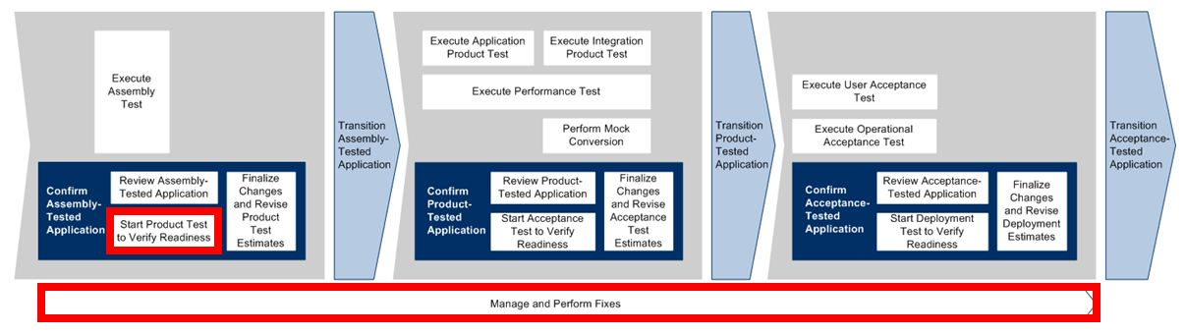

**Roles**

|  |  |  |  |
| --- | --- | --- | --- |
| **Role** | **ADM Task** | **ADM Responsibility** | **Description** |
| Project Manager |  | Management Oversight | Provides guidance on the [Team Status Report](https://accenture.desire2learn.com/content/enforced/9406-Pending/NCCC_Project_Work_Products/1_PM/Release_1/StatusRpt_FERS_R1_REF.doc?_&d2lSessionVal=YnoL4daZGC8ne2RyGf0cWMrk8). |
| Developer | 5723 – Start Product Test to Verify Readiness  5790 – Manage and Perform Fixes | Additional Performer (for ADM task 5723)  Primary Performer (for ADM task 5790) | Performs Product Test Readiness Testing on the application.  Reviews any defects that were communicated by the Test Team, assesses the defects and, if required, corrects the application code to remove the defect. |
| Team Lead | 5723 – Start Product Test to Verify Readiness  5790 – Manage and Perform Fixes | Additional Performer (for ADM task 5723)  Primary Performer (for ADM task 5790) | Reviews the defects, assesses the complexity and validity of the defect, and assigns the defect to members of the fix-it team.  Delegates portions of the application to members of the team to perform Product Test Readiness testing. |
| Test Team | 5723 – Start Product Test to Verify Readiness  5790 – Manage and Perform Fixes | Primary Performer (for ADM task 5723)  Additional Performer (for ADM task 5790) | Executes the product test and communicates defects to the fix-it team (i.e., the Application Build Team). |

**Participant Instructions**

**Prepare for the Product Test**

For this module you will need to refer to the Use Cases here:  
[Register Visitor (UC1)](https://accenture.desire2learn.com/content/enforced/9406-Pending/NCCC_Project_Work_Products/3a_App_Analysis/Release_1/UseCase_FERS_UC1_RegisterVisitor_R1_REF.docx?_&d2lSessionVal=YnoL4daZGC8ne2RyGf0cWMrk8)  
[Login Visitor (UC2)](https://accenture.desire2learn.com/content/enforced/9406-Pending/NCCC_Project_Work_Products/3a_App_Analysis/Release_1/UseCase_FERS_UC2_LoginVisitor_R1_REF.docx?_&d2lSessionVal=YnoL4daZGC8ne2RyGf0cWMrk8)  
[Update Visitor (UC3)](https://accenture.desire2learn.com/content/enforced/9406-Pending/NCCC_Project_Work_Products/3a_App_Analysis/Release_1/UseCase_FERS_UC3_UpdateVisitor_R1_REF.docx?_&d2lSessionVal=YnoL4daZGC8ne2RyGf0cWMrk8)  
[Register for Event (UC4)](https://accenture.desire2learn.com/content/enforced/9406-Pending/NCCC_Project_Work_Products/3a_App_Analysis/Release_1/UseCase_FERS_UC4_RegisterForEvent_R1_REF.docx?_&d2lSessionVal=YnoL4daZGC8ne2RyGf0cWMrk8)  
[Unregister from Event (UC5)](https://accenture.desire2learn.com/content/enforced/9406-Pending/NCCC_Project_Work_Products/3a_App_Analysis/Release_1/UseCase_FERS_UC5_UnregisterFromEvent_R1_REF.docx?_&d2lSessionVal=YnoL4daZGC8ne2RyGf0cWMrk8)  
[Use Case Diagram/User Scenarios](https://accenture.desire2learn.com/content/enforced/9406-Pending/NCCC_Project_Work_Products/3a_App_Analysis/Release_1/UseCaseDiag_FERS_R1_REF.docx?_&d2lSessionVal=YnoL4daZGC8ne2RyGf0cWMrk8)  
  
**Team Lead**

1. Click on the links above and download the Use Cases. To assist you during this module you may wish to refer to the [Component Class Detailed Design](https://accenture.desire2learn.com/content/enforced/9406-Pending/NCCC_Project_Work_Products/3b_App_Design/Release_1/CompClsDes_FERS_R1_WPC_REF.docx?_&d2lSessionVal=YnoL4daZGC8ne2RyGf0cWMrk8) and the [Application Development Standards](https://accenture.desire2learn.com/content/enforced/9406-Pending/NCCC_Project_Work_Products/4_Tech_Arch/Release_1/AppDevStd_FERS_R1_REF.docx?_&d2lSessionVal=YnoL4daZGC8ne2RyGf0cWMrk8).  
2. Review the Use Cases and find key Use Cases that represent critical scenarios to test the Readiness of the Application for the Product Test.  
3. Assign critical scenarios to team members to test. You may assign Use Case(s) to yourself.

**Developer**

4. Your Team Lead will have assigned you Use Cases.  
5. Review these Use Cases in preparation for the Product Readiness Test.  
6. Review the [Product Test Scenarios](https://accenture.desire2learn.com/content/enforced/9406-Pending/W4_Participant_Materials/Module_38/Prod_TestScen_FERS_R1_REF.xlsx?_&d2lSessionVal=YnoL4daZGC8ne2RyGf0cWMrk8) document (and associated [Product Test Conditions and Expected Results](https://accenture.desire2learn.com/content/enforced/9406-Pending/W4_Participant_Materials/Module_38/Prod_TestCond_FERS_R1_REF.xlsx?_&d2lSessionVal=YnoL4daZGC8ne2RyGf0cWMrk8)) and find critical scenarios to test the readiness of the Application for the Product Test associated with the Use Cases.  
7. Import the UI layer in the project:

a. Download the [UI zip file](https://accenture.desire2learn.com/content/enforced/9406-Pending/W4_Participant_Materials/Module_38/Appl_UILayer_FERS_R1_REF.zip?_&d2lSessionVal=YnoL4daZGC8ne2RyGf0cWMrk8) and unzip to a temp folder (eg, c:\temp) on your local drive.

b. Unzip the files in the temp folder.

c. Within the Eclipse Package Explorer, under the FestivalPortal_Participant project:

i. Right-click on the WebContent folder and select the **Import...** option.

ii. From the **Import - Select** window, select **File System** and press the **Next >** button.

iii. In the **Import - File System** window, next to the **From directory** text box, press the **Browse...** button.

iv. In the **Import from** directory window navigate to the temp folder and press the **OK** button.

v. In the **Import - File System** window, the **From directory** text box should contain the folder name. The left box below should contain the folder so it can be navigated. In the right box should be the list of .jsp files. If not, navigate to the appropriate sub-folder (in the left box) or another folder (in the **From directory** text box) to find the files.

vi. Once the files are found, click the checkbox next to all the .jsp files in the right box.

vii. Once all files are selected, click the **Finish** button.

viii. Once complete, you should see all the selected files listed under the WebContent folder. See screenshot for example:

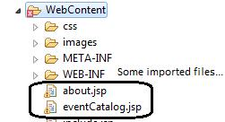

ix. If you are seeing some errors then clean the project by going to the **Project menu** and choosing **Clean...**

8. Within Eclipse, run the application and manually execute the test scenarios by starting the application in your internet browser from the login page (index.jsp).  
9. If defects are found do not correct them at this time. Code updates will be done during the Support Product Test step.

a. The goal is to integrate the UI with the rest of the code and test that the full appplication appears to be functioning without any catastrophic errors (eg, cannot load page, cannot login or cannot navigate to other pages).

b. You can log any defects you may find in the blank [Defect List](https://accenture.desire2learn.com/content/enforced/9406-Pending/W4_Participant_Materials/Module_38/DefectList_FERS_R1_TMPL.xlsx?_&d2lSessionVal=YnoL4daZGC8ne2RyGf0cWMrk8) provided by the faculty.

10. Check in any updated code, make sure the code can compile and then inform management that the team is ready for the system test.  
11. The Team Lead must communicate to the management that the team is ready for the Product Test.

**Support Product Test**

12. The Test Team will send you a list of defects after a run of your application.

a. Ask questions if you do not understand the defects by changing the status and sending it back to the test team with your questions.

b. Otherwise, make fixes to the code and re-unit test and regression test (product test the code and surrounding functionality to make sure everything else is working).

13. **Team Lead only**: When all the defects appear to be fixed, notify the test team by email, providing the updated defect list.   
  
***Note: All defects must be fixed and closed by the test team by the end of this module.***

**Hints and Tips**

* Perform some exploratory testing. Bugs typically move in groups; therefore, if you find one, you may want to look for more in that area.
* Fix as many defects as possible before deploying another build to the test environment.
* Reflect on what you have learned in your Professional Skills Training about conducting an effective Team Status Meeting.